# **Euclid Installation Guide**

This manual provides instructions on how to properly install and configure Euclid application on your desktop or personal computer.

1. Before installation, check if your computer meets the minimum requirements shown below:

• Windows 7 operating system or later,

• Java Runtime Environment (JRE) version 1.7.0 or higher,

• 500MB RAM

• 50MB disk space

• Pentium 2.2 GHz or faster (recommended 3.2 or higher for better performance)

1. Make sure that you have a copy of Euclid installer in your device.
2. Double click the installer or right-click the mouse and select “**Open**”.

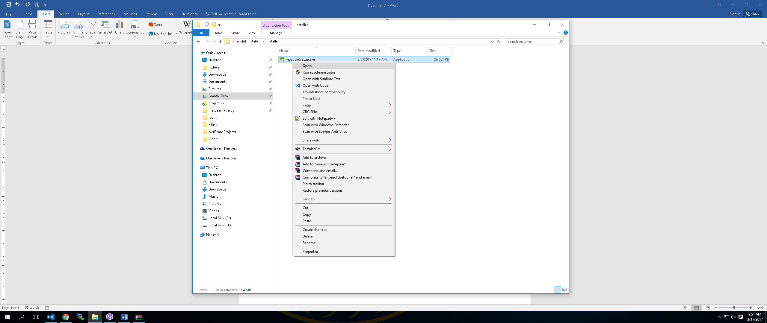

1. Select the Destination Location. By default, Euclid will be installed in the user’s **My Document** folder. Click **Browse** to modify the location. The current user will not be able to install the application in the **Program Files** unless logged in as administrator.

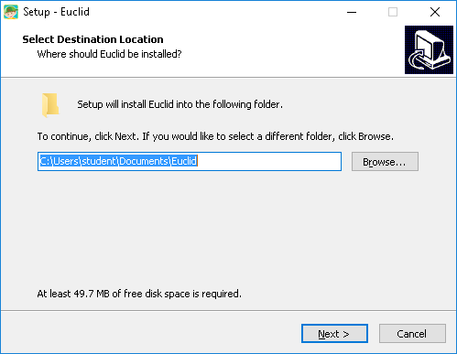

1. Click **Next** to proceed.
2. **Select Additional Tasks**. Select the checkbox if you want to create an application shortcut in your desktop.

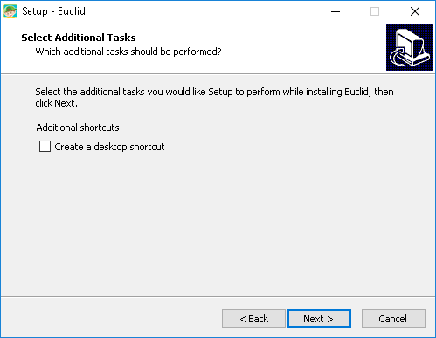

1. Click **Next** to proceed.
2. The application is now ready to install. Click **Install**.

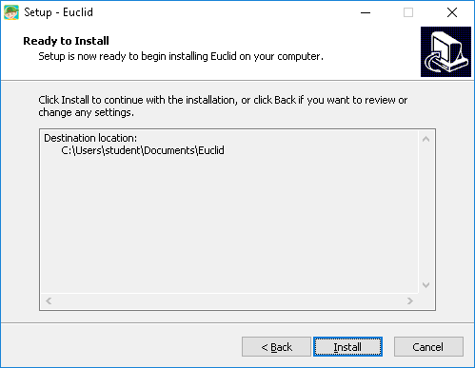

1. The application is now installing. Wait until the installation is finished.

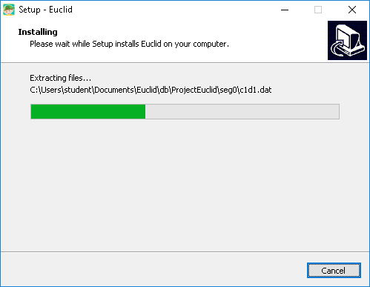

1. The application is already installed in your device. You can select the checkbox to launch the application. Click **Finish** to exit the setup.

